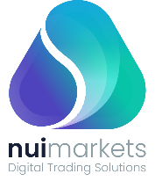 | Growth capital for Nui Markets: Simplifying the world of commodity trading with our efficient and transparent trade platform.

Executive summary
Nui Markets (New Zealand) is a platform for agricultural commodity trading. This platform is used by 287 companies in 47 countries. Since inception in 2016, more than 755m NZD of GMV has been traded through the platform. With commodity spot trading increasingly turning digital and our foothold in the market growing, we have identified an opportunity to rapidly expand and consolidate the platform globally. We are now seeking 10m NZD of equity capital at a 51m NZD pre-money valuation - enabling us to become the industry leader in commodity trading.

Use of funds:
- Expand our “platform as a service” offering in new verticals
- Become a platform operator in our chosen dairy markets
- Enhance platform features to add more value to our users’ trading
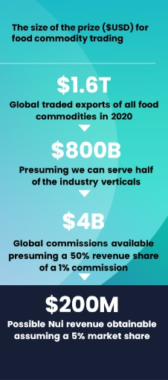

Problem and Opportunity
Commodity spot traders and major exporters rely on personal relationships. Typical sales teams communicate directly with customers on a one-to-one basis across many channels such as Whatsapp and email. Agreeing and administering trade of agricultural commodities is thus labour-intensive and difficult to scale. COVID-19 has accelerated the uptake of digital solutions for traditional trade. However, existing solutions built on generic frameworks like Magento or Mirakl fail to cater to the complex workflow requirements of agricultural commodity export/import.

As a result, traders suffer from poor price discovery, high costs of searching for trading partners, administrative inefficiencies, pressured margins, and increased counterparty risk when trading with unfamiliar partners.

Solution
We’ve built a fit-for-purpose platform for agricultural commodity trading which our customers and users love. Our proprietary platform powers individual exporters to sell directly to their buyers, as well as being used for multi-seller marketplaces. We cover the seller’s workflow from placing an offer and managing tenders, right through to managing post-trade execution and documents.

We have three streams of revenue: implementation fees, subscription charges, and trade commissions.
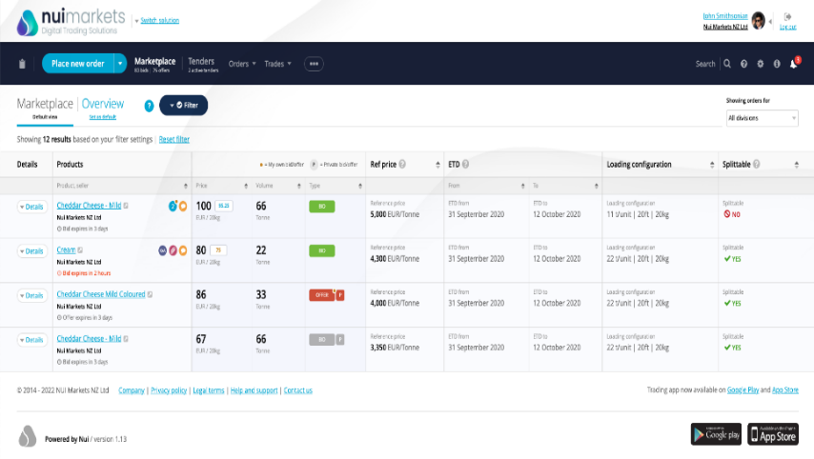
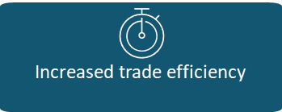

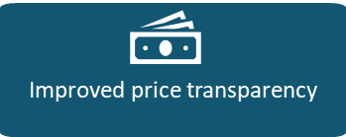





Traction
As of the end of February 2022, Nui had over 287 companies accessing a Nui platform, in 47 countries. In the 12 months to the end of Feb 2022, over 1,860 trades were completed with a GMV of over 282m NZD. Revenue for FY2021 was 1.456m NZD. We have grown exponentially in our four years of operating the marketplace – with a Revenue CAGR of 53.9% and a GMV CAGR of 61.5% between FY2017 and FY2021.
The Team
Kevin O’Sullivan
CEO

Our CEO Founder Kevin O’Sullivan has rich experience in financial markets, international Forex
trading and in primary industries. Kevin is complemented by a technical team of software developers

(led by a comp-sci PHD) and an international team of commodity trade experts (across NZ, US and EU).

Nui’s Board features industry leaders from the likes of Fonterra’s Global Dairy Trade, KPMG,
and Open Country Cheese Ltd (major NZ exporter).

Growth Plan
In the past year we have focused on fine-tuning our platform to add as much value as possible to our users’ trades while maximising our ability to monetise GMV traded through the platform. We now see a major opportunity to grow our footprint with a three-pillar strategy:
3. Enhancing platform features to drive revenue growth
2. Becoming a platform operator
1. Expanding our “platform as a service” offering in existing and new verticals

a. Double down on Dairy – with Dairy being our lighthouse vertical, we intend to build on existing marketplace successes such as DAO EU to aggressively expand our platform with Dairy marketplace operators worldwide. We will also build up an Asian buyer base which all international marketplaces can sell into.

b. Ethanol marketplace in Brazil – we are in advanced negotiations in Brazil for an ethanol marketplace, leveraging existing commercial relationships.

c. Pursue new verticals – meat, eggs, fertilizer, grain, animal feed, carbon ETS and biofuel.
By adding further value to users’ transactions, we can capture more revenue on the platform.

a. Improve trading flexibility with new order formats and moving beyond spot buying.

b. Increase trade efficiency by incorporating logistics, payments, and trade data.

c. Supporting our customers’ business initiatives with tracing and sustainability.

d. Boosting user engagement through providing targeted offers, smart insights for buyers and improved comms.
This is a strategic advancement for Nui. We see the opportunity to move into the role of a platform operator to consolidate international markets and maximise revenue.

DAO EU (Dairy) – In March 2022, we concluded the acquisition of our largest customer, Dairy Auctions Online, with a significant market share in the EU.

Nui Markets North America - In April 2022, we will launch Nui Markets North America.
This will expand Nui’s presence in the North American Dairy Market, where we already provide single seller platforms.

Business Plan
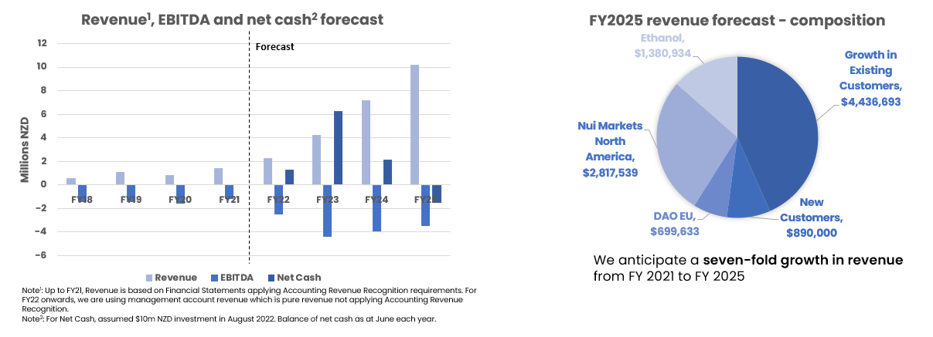
Use of Funds – 10m NZD
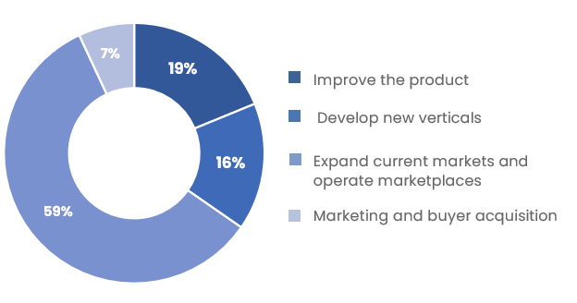
Investment Opportunity
We are raising 10m NZD at a pre-money valuation of 51m NZD.
This will provide a 24-month runway during which we are targeting over 200% revenue growth.
Our previous funding round was led by New Zealand institutional investors but in order to grow on the world stage, we need to be backed by truly global investors. We are seeking Seed/Series A tech investors in Europe with a proven record in supporting platform software companies to scale internationally.

Support the next stage of our growth, as we become the leading commodity trading platform globally
kevin@nuimarkets.com

