**Website objectives**

1. Simplicity and look – easy to find key information
2. Visually appealing
3. Who are we
4. Stress we’re NZ owned and operated
5. What do we want to achieve
6. What do we have to offer
7. Website to support sales / growth of PRISMA
8. Opportunity to engage with (potential) clients and understand their needs
9. Needs to be manageable – don’t want to spend excessive time to manage a website
10. Affordable to set up and maintain
11. Opportunity to use as a webshop in the near future to sell webinars, education courses and allow viewers to check my blog as well as resources they can use for free (this to attract traffic).
12. Search engine optimisation – ensure that PRISMA is number one when specific word searches are done on google or other web engines
13. Good overview of services and how to engage with PRISMA
14. Ability to analyse web traffic for follow and sales opportunities
15. Content marketing opportunity – I’m only on Linkedin as Jack Crutzen but not as PRISMA. I don’t have a facebook page etc. – what’s best to integrate/optimise the PRISMA presence.
16. Chatbox or email opportunity – so that there is some sort of contact due to webpage visit – for example an automatic pop up to sign up for newsletter/frequent blog etc. – this to get a list of interested companies/persons to connect with
17. How does the web site look on a mobile or tablet?
18. Can I easily change if I evolve to PRISMA Group Ltd.
19. Good photos/graphics/letter type / colour scheme / art

**Web shop / Training / Knowledge database**

Objective is to sell webinars or training to individuals or in-house company training. I also have the idea that Facility Management professionals can buy templates, reports and articles etc. This would save them lots of time.

A website like this could be an idea <https://www.thinksharp.co.nz/courses>

Alternatively, I could use somebody elses as web portal and retail channel to promote by courses/webinars etc

The webshop is not the highest priority but will have to be developed later this year or next year, pending economical recovery.

**Helpdesk Portal (not now / near future)**

Website needs to have the opportunity to have a quick link to a client portal – if clients needs to access to PRISMA helpdesk and reporting portal

**Some other things for consideration – based on Openhost account**

**Review email set up**

[jack@prisma.co.nz](mailto:jack@prisma.co.nz)

[jackcrutzen@prisma.co.nz](mailto:jackcrutzen@prisma.co.nz)

[info@prisma.co.nz](mailto:info@prisma.co.nz)

I also need to secure PRISMA Group name.

There is a PRISMA Group in USA - <https://prismagp.com/about.html>

As well as <http://prisma-statement.org/>

There is also this one on Linkedin : <https://www.linkedin.com/company/prisma-advertising-print/>

**PRISMA Group Ltd** (the name intend to take) has several independent components such as:

(check with Parwaiz my accountant)

Prisma Consultancy

Prisma Ad Interim Management

Prisma Contract Management

Prisma Procurement

Prisma Asset Management

PRISMA Audit : H&S, Risk management, Maturity Reviews, Cleaning Scan, Spend analysis, Procurement Audit, Energy management audits, BMS audits

Prisma Education : (in-house) training, lecturing, presentations

Prisma Training & Development, Coaching & Mentoring

Prisma Project Management

**Additional email accounts**

I need to be able to give emails to service partners of PRISMA so that they can communicate from PRISMA perspective : eg. [ricky@prisma.co.nz](mailto:ricky@prisma.co.nz) or [warren@prisma.co.nz](mailto:warren@prisma.co.nz)

**To discuss with account = create PRISMA Group Ltd.**

Logo to be created / logo PRISMA Group ltd.

With that all the relevant paper head, business card, power point presentation as well as capability document

**Other business documentation to be developed**

Review current logo – also with Group Logo in mind

Powerpoint template

Currently happy with letter head

Capability document / template to be created

Marketing documentation such as capability document / powerpoint slide deck lay out

Maybe I want to have a logo on my car?

Need a logo screen – behind me when I’m on Zoom, Skype, MS Teams etc. (can print this or printed on perplex ?)

**To discuss other social media set up : Facebook Linkedin, Instagram etc.**

Need to set up Linkedin company profile

Facilities Management related photos

<https://www.istockphoto.com/nz/photos/facility-management?mediatype=photography&phrase=facility%20management&sort=mostpopular>

<https://www.shutterstock.com/search/facility+management>

rather boring

Note that PRISMA is more than only Facilities Management

**Who are my competitors?**

Niche FM - <https://nichefm.co.nz/>

GregMooe Group - <http://gregmoregroup.com/about-us/>

WTP Partners

Kingfisher Group - <https://www.kingfishergroup.org.nz/>

DavisWyatt - <https://davis-wyatt.com/about>

**Other Prisma’s in the world**

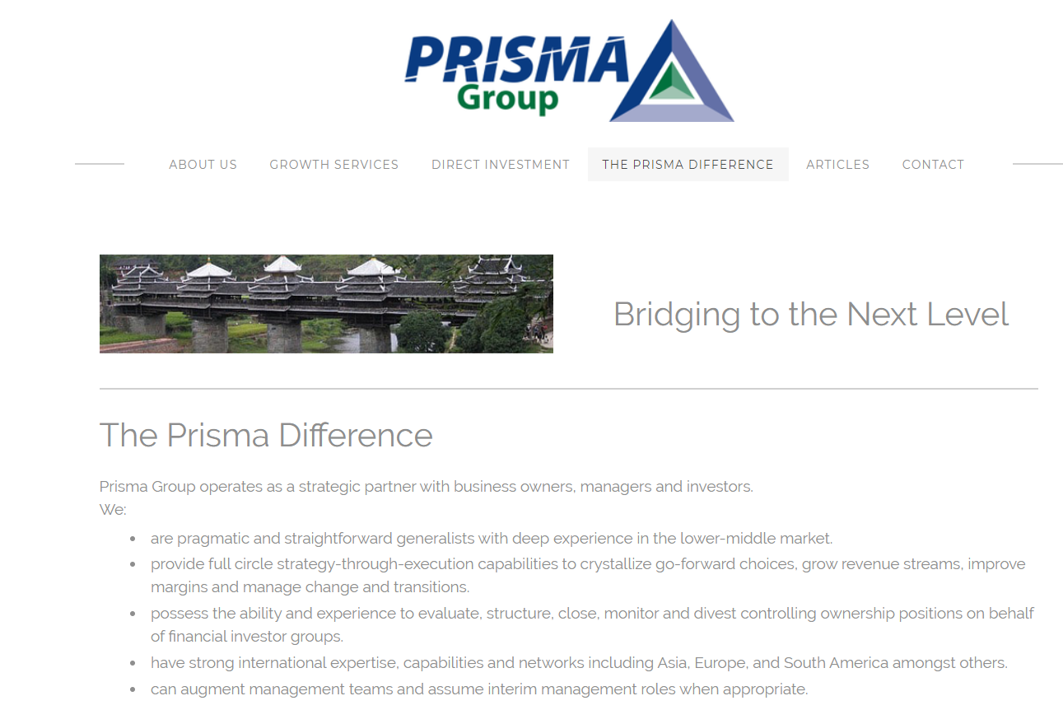

**Some thoughts on text for website – Wim – this is only first draft/go at it – will do more on this over the next few days.**

(happy to have this rewritten by a professional text writer)

**“Who are we”**

Established in 2015 and based in Auckland but operation New Zealand wide, PRISMA Facilities Management provides consultancy support across New Zealand and has the capability and resources to deliver our services overseas.

PRISMA is an owned and operated New Zealand company.

The fundamental philosophy of PRISMA Facilities Management has always been to ensure that consultancy services of the highest quality are consistently delivered to our clients. We are committed to fully delivering the objectives of all our clients and, wherever possible, exceeding their expectations.  
  
We strongly believe that by maintaining our own consultancy service excellence we will retain and enhance our relationships with our clients through supporting the achievement of their own business objectives.

Our experienced and dedicated team of consultants have successfully delivered projects to both public and private sector clients. They have also all worked with client organisations and on behalf of service providers in both bidding and operational enhancement roles. The knowledge and expertise that this wide-ranging experience gives us enables PRISMA Facilities Management to add significant value to every consultancy project, supporting the identification of improvement opportunities, the achievement of best practice and the realisation of what may otherwise remain aspirations.

**PRISMA values**

Champions Do Extra

> Taking pride in what we do and adopting continuous improvement as Business As Usual (BAU); > We do the right thing at the right time.

Grow or Die

> Continually assessing opportunities for growth and improvement.

Building Relationships

> Building long term partnerships with our clients that bring reputation and repeat business.

No Dickheads

> Show humility – character is as important as talent; > Treat everyone with respect and honesty; > Lead by example in everything we do; > Consider our colleagues when making decisions in relation to service delivery, working together to achieve success for all.

Good to Great

> Identify and develop both leaders and specialists so that the market raves about our abilities and delivery; > Commitment - We care; > Invest in people and community – there is much more to it than profit!

**PRISMA mission statement ( to long 😊 )**

Develop, secure and then manage all client relationships to maximise profitability through the delivery of a one stop shop providing world class skills, experience, technology, services and solutions, pursuing and delivering on additional opportunities to ensure client retention and enhance our reputation to secure new business.

PRISMA Facilities Management is a New Zealand based management consultancy business providing professional advisory and support services in Facilities & Asset Management, Contract Management & Procurement.

PRISMA is an enabler of business success by focussing on what makes the business work!

**PRISMA Facilities Management operates in:**

* Commercial
* Not for Profit
* Defence
* Health
* Retail
* Education & Training
* Manufacturing & Production
* Transport & Infrastructure
* Local, Regional and Central Government

(very similar to Niche FM)

PRISMA Facilities Management have built a reputation for finding customer business focussed long term, sustainable solutions for a diverse range of clients. PRISMA provides a “one stop shop” solution for clients in the “built environment” and …

Our team of Professionals are leaders in their fields and have a proven track record of getting things done. We adopt a unique team approach, deploying our multi-disciplinary resources to best suit your changing needs. Whether it is maximising returns on your investment, increasing business and operational performance, contract and facilities management, filling an operational gap or simply supporting your teams to achieve efficient delivery of a specific task, we can help.

Read our capability statement (link on the page) for more information or please contact us on …

See <https://www.hospitality-group.nl/>

Strategy/Vison/objectives

**Clients**

PRISMA supports clients in multiple market segments, past and present, from smaller enterprises throught to multinationals and blue-chips

**(list/logo of all clients – I have a pptx of one page with all logos of clients).**

Many of these clients are repeat clients

**Why work with PRISMA**

The benefits of selecting PRISMA include:

**A company which is a New Zealand owned and operated** entity with intimate knowledge of working within the New Zealand environment. We are a locally owned streamlined company that is agile and flexible with proactive management able to make fast decisions with no corporate inertia.

**Significant IP and Presenting Low Risk** – PRISMA has extensive knowledge of managing a large building and services portfolio. We have utilised that knowledge in the development of this proposal. Selecting PRISMA presents a low risk solution for MHP due to this comprehensive knowledge, that does not need to be learned before or during the contract delivery - allowing us to:

**A company with significant in-house FM knowledge and experience** – PRISMA has a wealth of knowledge providing FM services and can draw on best practice work from many previous roles and engagements and the vast technical experience of our service partners and contractors. We provide technically trained and proficient resources who manage works from beginning to end to 100% satisfy contract deliverables. PRISMA aim to be the most capable and competent service provider within the FM industry and we will work seamlessly with MHP in the delivery of this contract.

**A company with unique capabilities** – PRISMA has a wide range of proven in-house capabilities and access to service partners with further capabilities. In-house capability includes FM, Asset Management, Project Management, Procurement Management, Contract Management, Account Management, Business/Data Analysis, Process Development, Business Strategy and Mentoring. Our service partners provide capacity for these same functions but also specialise in Workplace Management, Property Management, Engineering, Building Services Optimisation, Security Strategy & Risk Assessments and H&S reviews.

**A company with leading edge information technology systems which allows it to provide much more than physical works** – PRISMA will utilise simPRO to provide a best in class information system to ensure we can collate relevant data and turn it into information.

**A company whose Senior Management Team is dedicated to the success of this contract**– PRISMA recognises the importance of the success of this contract to our business and has dedicated our senior management team to assist with the proactive management of the contract itself. PRISMA will commit whatever it takes to ensure a successful delivery to MHP. We are committed to provide an exceptional delivery to MHP as a cornerstone of our philosophy and proof that an alternative and independent FM Management model is leading for the maturity of our profession.

**Efficiency and Cost Effectiveness** – PRISMA provide a commercially competitive offering through simplicity in contract charges – together with leveraging off a proven supply chain, we believe this is a model that reduces cost for our clients as well as add value to the wider business.

**A company with strong culture relating to Health and Safety & Human Resources** – PRISMA recognise the importance of our staff and health and safety systems alongside human resource programmes for training/accreditations aim to keep our staff learning, safe, motivated, and engaged to deliver excellence in service delivery.

**A company whose approach to partnering is paramount to success and extends past the client/service provider relationship to include customers, suppliers and other key stakeholders** – The PRISMA service delivery is the sum of all parts, including successful supply partnerships, driving value from the supply chain to innovative IT systems to keep our clients, customers and key stakeholders engaged throughout the entire workflow process. PRISMA fully support honest and transparent partnering style relationships across all aspects of service delivery to improve performance, exceed customer expectations and to drive value to all stakeholders.

See <https://www.grosvenorproperty.com.au/who-we-are/>

**Our Team**

Photo of all team members

Photo of individual team members – click on them – get a profile

When you scroll over photos – you see role and how to contact them (phone, email, linkedin etc.)

**Services**

PRISMA provides the following services:

Prisma Consultancy

Prisma Ad Interim Management

Prisma Contract Management

Prisma Procurement

Prisma Asset Management

PRISMA Audit : H&S, Risk management, Maturity Reviews, Cleaning Scan, Spend analysis, Procurement Audit, Energy management audits, BMS audits

Prisma Education : (in-house) training, lecturing, presentations

Prisma Coaching & Mentoring

Prisma Project Management

Then click on one of them and you see more detail on what we can offer as services

PRISMA Consultancy

* Strategic Facilities Management
* Facility and Facilities Management Health Checks
* Operational FM and Asset Management
* Workplace Assessment and Management
* Development of FM Operational Manuals and Processes
* Operational Expenditure (OPEX) Budget Planning
* Capital Expenditure (CAPEX) Budget Planning
* Contractor Management
* Asset Condition Assessments
* Whole of Life Planning / Long Term Asset Management Plans
* Compliance Management
* Soft Landings
* Helpdesk Management review and strategy

PRISMA ad interim management

* Provide …
* Undertake maturity assessment to advise on what kind of FM and AM competences you need
* Provide temporarily resources to support your project

PRISMA Asset Management

* Strategic Asset Management
* Operational Asset Management & Planning
* Asset and Asset Management Health Checks & Maturity Reviews
* Asset Condition Assessments
* Asset Data Analysis and Reporting
* Whole of Life Planning / Long Term Asset Management Plans
* Compliance Management
* Building Services Review, improvement plans
* Maintenance strategy and maintenance plans

See also <https://www.assetivity.com.au/consulting.html>

PRISMA Procurement

* Interim Facilities & Asset Management
* Performance Management
* Supplier Performance Assessment and supplier management
* Category Analysis / Spend analysis
* Data Analysis and Reviews
* Full RFx documentation
* Scope Development
* Evaluation frameworks, evaluation and moderation
* Contract Implementation & Transition management
* Staff Management, Training and Inductions
* Business & Risk Continuity Planning
* Technical Specifications and Key Performance Development
* Tender and Evaluation Management

See also <https://www.mb-associates.co.nz/#services>

See <https://www.grosvenorprocurement.com.au/>

Prisma Contract Management

* Development of contract strategy and contract management plans
* Operational Management of contracts & contractor performance assessment and management
* Helpdesk management
* Contract Reporting, performance analysis and improvement plans
* Spend analysis / procurement strategy across all contracts
* Development of FM Operational Manuals and Processes
* Operational Expenditure (OPEX) Budget Planning
* Capital Expenditure (CAPEX) Budget Planning
* Contract re negotiations

PRISMA AUDITS & Improvement Plans

* FM & Asset Management Maturity Review and improvement plans
* H&S assessment and improvement plan
* FM & AM risk assessment and improvement plans
* Building Services Review, improvement plans and maintenance strategies
* Energy management audits
* Building Management System review
* Security Assessment
* Cleaning Scan – optimise cleaning contract management and spend profile
* Procurement Assessment, spend analysis

See also <http://wtpartnership.co.nz/services/advisory/facilities-management/>

PRISMA Project Management

* Project Management Office (PMO)
* Office Fits Outs and Relocations
* Plant & Machinery Upgrades
* Refurbishments
* Technical Due Diligence
* Capital Renewals & Replacement Plans

PRISMA Training & Development, Mentoring & Coaching

* Support & Leadership for Facilities & Asset Management Professionals
* Mentorship for Facilities & Asset Management Teams and Individuals
* Training and Education Workshops (in-house, off-site)
* Team and Individual competences and capability assessments and improvement roadmaps
* Present at conferences, summits etc.

See also <https://www.switchedonlearning.net/course?courseid=mentor>

<https://www.coachingmentoring.co.nz/training>

<https://www.rosemarykillip.com/>

Contact Us

Similar to Niche FM

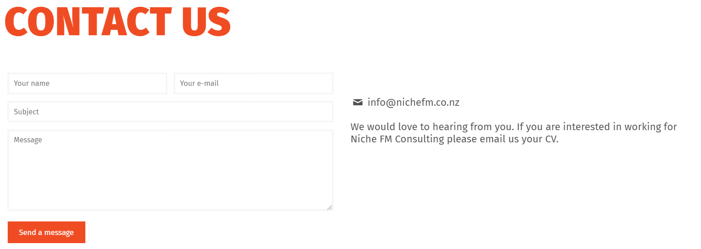

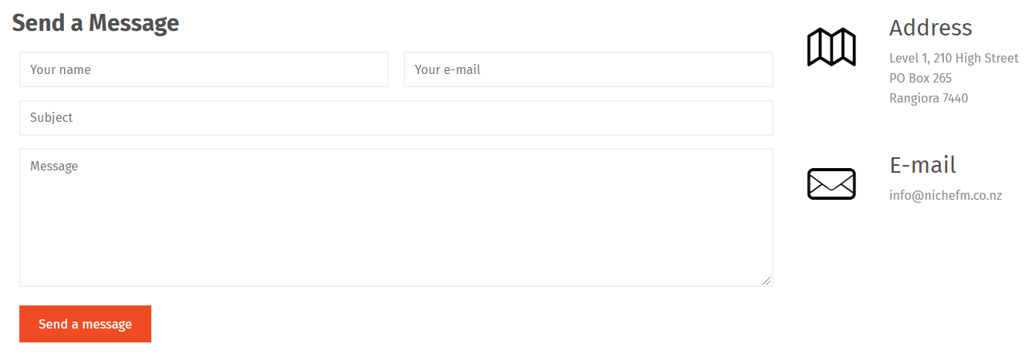

There is an email – info@prisma.co.nz

I suggest we add google maps – where is our office

Case study

Similar to <https://nichefm.co.nz/case-studies/>

Photo/logo with the name of the case study and a short description

Click on it

You then get a summary

* Client Name
* PRISMA Facilities Management brief
* Project Approach
* The Solution
* Results